Business Question and Visualization Report
Attribute | Details
Team ID | individual
Project Name | Smartphone Usage, Digital Addiction & Well-Being Analytics
Maximum Marks | 5 Marks
Project Overview
Visualization development for this project refers to the process of translating complex human behaviour, smartphone engagement metrics, and psychological indicators into graphical data representations. The goal is to provide clear behavioural tracking and diagnostic analytics that enable educators, health professionals, and users to gain deep insights into screen time habits, trace structural patterns of digital over-reliance, and make informed structural decisions toward promoting healthier tech-life balance.

Business Questions and Visualisations
1. Daily Overconsumption Breakdown
- Business Question: What is the average distribution of screen time across daily activities (social media, gaming, and work/study) for different addiction severity labels?
- Visualization: Clustered Bar Chart comparing average hours spent on social_media_hours, gaming_hours, and work_study_hours grouped by addiction level.
- Screenshot of Visualisation:
- 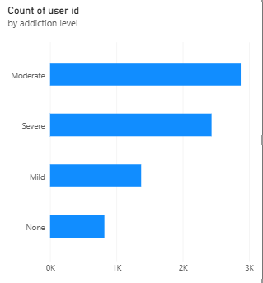
2. Weekend Over-Reliance Trends
- Business Question: How does weekday screen time compare to weekend screen time across different user age groups?
- Visualization: Clustered Column Chart or Line Chart displaying daily_screen_time_hours versus weekend_screen_time across custom age buckets created from age.
- Screenshot of Visualisation
- 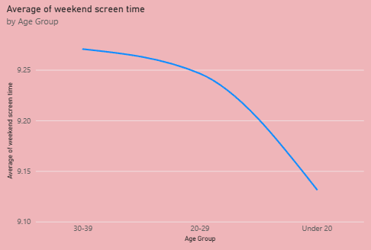
3. Notification and Interaction Triggers
- Business Question: Is there a correlation between the number of notifications received per day and how frequently a user opens their apps?
- Visualization: Clustered bar chart showing the relationship between notifications_per_day (X-axis) and app_opens_per_day (Y-axis), color-coded by the binary addicted label.
- Screenshot of Visualisation
- 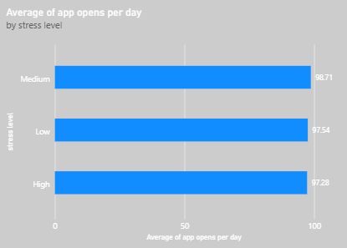
4. Psychological & Well-Being Impact
- Business Question: How do varying stress levels directly align with documented addiction categories?
- Visualization: Donut Chart showing the count of users cross-tabulated by stress level (Low, Medium, High) and addiction level
- Screenshot of Visualisation:
- 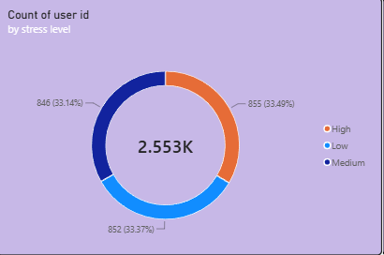
5. Biological Sleep Deprivation Assessment
- Business Question: How does an increase in daily screen time impact the total hours of sleep a user gets?
- Visualization: Scatter chart showing average daily_screen_time_hours as columns and average sleep hours as a line chart mapped against user demographics or index groups.
- Screenshot of Visualisation
- 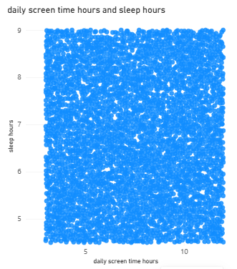
6. Academic and Professional Vulnerability
- Business Question: Which gender demographics report the highest negative impact on their academic or work productivity due to smartphone usage?
- Visualization: Clustered bar chart filtered exclusively for users who answered "Yes" to academic_work_impact, segmented
- Screenshot of Visualisation:
- 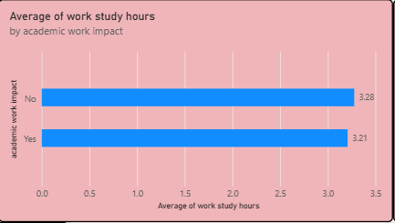
7. Interaction Fatigue & Sleep Impact
- Business Question: How does addiction of usage affect sleep duration, and does high stress amplify this reduction in sleep?

- Visualization: Clustered bar chart mapping addiction level on the y-axis against sleep hours on the x-axis with the data points separated or colored dynamically by stress level (Low, Medium, High).

- Screenshot of Visualisation:

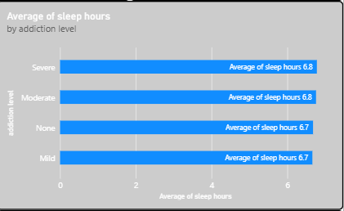

8. Total Critical Behavioural Health Overview
- Business Question: What are the key high-level system-wide performance indices regarding daily digital usage and general addiction penetration rates?
- Visualization: KPI Cards Block & Gauge Charts highlighting overall dataset benchmarks: Average notifications per day, average daily screen time, and the overall dataset proportion of individuals labelled as high-risk under addicted label.
- Screenshot of Visualisation
- 